**LIBRARIAN-TO-LIBRARIAN NETWORKING SUMMIT 2/2/2013**

***Reattaching a Single Signature to Its Original Case***

**Scenario #1 Reattaching Signature with STAPLES ONLY**

Item has only one staple or has no staples

1. Staple again “as is” in same staple holes
2. If staple holes are torn, staple again in different areas
3. If staple holes need mending can use desk tape, cloth tape or paper and adhesive to mend
4. Staple through folds of signature

**Scenario #2 Reattaching Signature with THREAD ONLY**

Item has only one staple or has no staples

1. Remove partial or rusty staples from item **see image #1**
2. Thread needle **see image # 2**
3. Secure front half of pamphlet with Mylar (or folded paper) and paper clips
4. Sew through staple holes “as is” **see image # 3**
5. Pull threads tight in the direction you are sewing and tie off

with a square knot [right over left, left over right]

1. If staple holes are torn, punch holes in different areas and sew through holes
2. If staple holes need mending can use desk tape, cloth tape or paper and adhesive to mend
3. Punch through the mended holes and sew

**NOW IT’S YOUR TURN!**

**Scenario #3 Reattaching Signature with Staples or Sewing Using a MANILA FOLDER For Cover**

Stapling item only

1. Remove partial or rusty staples from item
2. Cut manila folder 1/8” taller and 1/8” wider than signature
3. Staple again “as is” through manila folder and signature
4. If staple holes are torn, staple again through manila folder and signature in different areas
5. If staple holes need mending can use desk tape, cloth tape or paper and adhesive to mend
6. Punch through the mended holes from the inside of signature and staple again through original holes, manila folder and signature

Sewing item only

1. Remove partial or rusty staples from item
2. Cut manila folder 1/8” taller and 1/8” wider than signature
3. If staple holes need mending can use desk tape, cloth tape or paper and adhesive to mend
4. Punch through the mended holes
5. Stabilize pamphlet and folder with guarded paper clips
6. Sew through manila folder and signature

**Scenario #4 Reattaching Signature with Staples or Sewing Using a PAMPHLET BINDER For Cover**

Stapling item only

1. Remove partial or rusty staples from item
2. Cut binder 1/4” taller and 1/4” wider than signature
3. Staple again “as is” through binder and signature in same staple holes
4. If staple holes are torn, staple again through binder and signature in different areas
5. If staple holes need mending can use desk tape, cloth tape or paper and adhesive to mend
6. Punch original holes through the mends
7. Stabilize pamphlet and folder with guarded paper clips
8. Staple again through binder and signature

Sewing item only

1. Remove partial or rusty staples from item
2. Cut binder 1/4” taller and 1/4” wider than signature
3. If staple holes need mending can use desk tape, cloth tape or paper and adhesive to mend
4. Stabilize pamphlet and folder with guarded paper clips
5. Punch through the mended holes and sew through binder and signature

***Reattaching a Text Block to Its Original Case***

**Scenario #1 Reattaching Text Block with ADHESIVE ONLY**

Item is partially or fully disconnected from case

1. Disconnect text block from case if separation is only partial
2. Glue down any loose paper
3. Place text block spine up between two bricks
4. Apply adhesive to spine of text block **see image # 4**
5. Align the spines of case and text block and rub down with bone folder **see image # 5 & 6**
6. Remove book from bricks
7. Insert wax paper between front and back covers
8. Be sure wax paper is pulled snuggly into the gutters
9. Place book spine down between two bricks and let dry overnight

**Scenario #2 Reattaching Text Block with ADHESIVE AND PAPER**

Item is partially or fully disconnected from case

* 1. Disconnect text block from case if separation is only partial
  2. Glue down any loose paper
  3. Cut paper spine lining
     + 1. Height should be: height of text block minus 1/8”
       2. Width should be: 1½” plus width of the spine
  4. Place text block spine up between two bricks
  5. Apply adhesive to spine of text block
  6. Fold paper in half, center paper on spine and rub down spine (remember to pinch/rub down sides) **see image # 7**
  7. Remove text block from bricks and align text block in case
  8. Insert wax paper strips between loose flaps and text block
  9. Starting with the front of the book, insert paste off sheet and apply adhesive to loose flaps, close book – repeat for back of the book **see image # 8**
  10. Place rods in outer hinges, align spine at a 90° angle
  11. Be sure wax paper is pulled snuggly into the gutters
  12. Place Plexiglas or board on top of book and allow to dry overnight

**IMAGES FOR PROCEDURES *Reattaching a Single Signature***

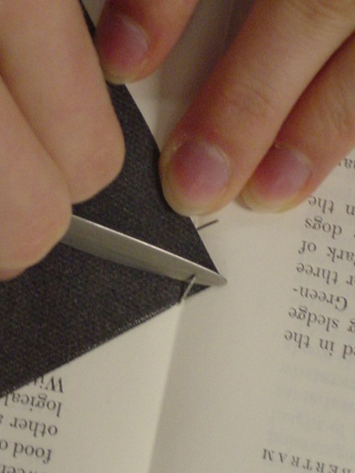 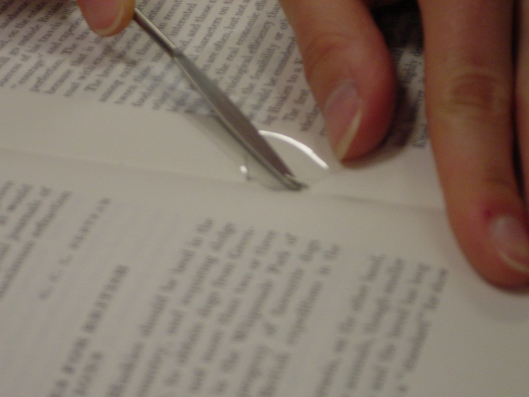

**Image #1 Removing Staple Image #1 Removing Staple with Mylar**

**With Paper**



**Image #2 Threading the Needle**

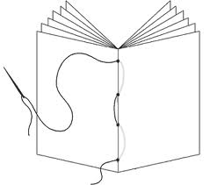

**Image #3 Sewing Pattern**

**IMAGES FOR PROCEDURES *Reattaching a Text Block***

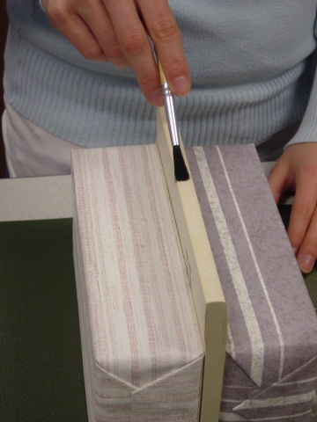 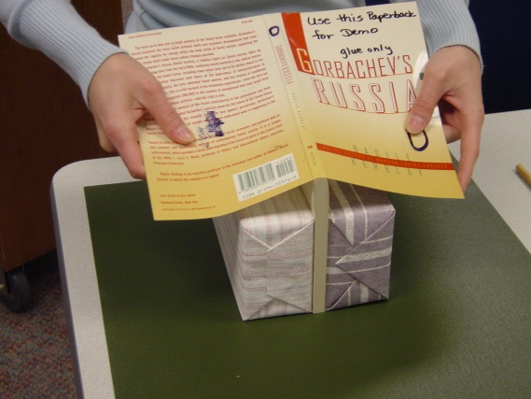

**Image # 4 Image # 5**

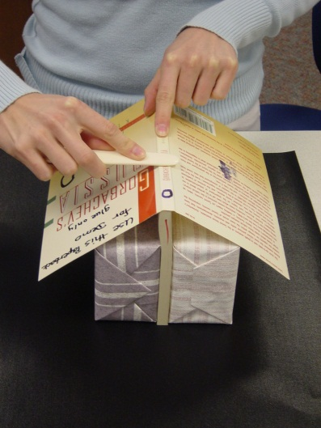 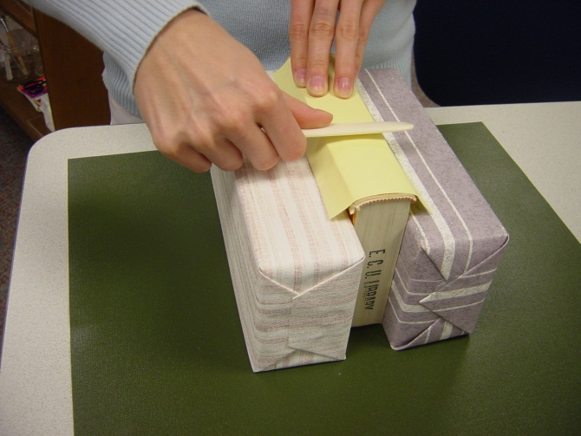

**Image # 6 Image # 7**

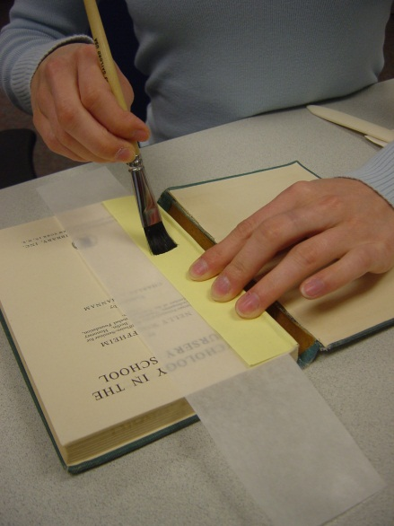

**Image # 8**

**Supply and Tool List Reattaching a Single Signature**

**Librarian-to-Librarian Networking Summit 2/2/2013**

**Scenario #1**

Adhesive/paper strips

Bone folder

Brush/Jar with water/paper towels

Paste off sheets

Scissors

Stapler with staples

Tape

**Scenario #2**

Awl

Brush/Jar with water/ paper towels

Paper/adhesive

Protective guards for removing staples

Staple remover

Tape

Thread with needle

**Scenario #3**

Adhesive/Paper strips

Awl

Bone folder

Brush/Jar with water/paper towels

Large manila folder or something similar

Needle/thread/scissors

Paper cutter/ruler/ a knife of some kind/cutting mat

Polyester with clips

Spatula or staple remover

Stapler with staples

Tape

**Scenario #4**

Adhesive/ brush

Binder

Copy paper

Needle/thread/scissors

Paper cutter/ ruler / a knife of some kind

Spatula/staple remover

Stapler with staples

Tape

Jar with water/paper towels

**Reattaching a Text Block to its Original Case**

**Scenario #1**

2 bricks

2 strips of wax paper

Adhesive

Bone folder (or something similar)

Brush

Jar with water

Paper towels

**Scenario #2**

2 bricks

2 rods

2 strips of wax paper

Adhesive

Bone folder (or something similar)

Brush

Jar with water

Paper for lining

Paper towels

Plexiglas or board

Scalpel or knife

Scissors or paper cutter

Paste off sheet